Counting, permutations, and Combinations

Counting principle and factorial

Counting outcomes using tree diagram
Tree diagrams display all the possible outcomes of an event. Each branch in a tree diagram represents a possible outcome. Tree diagrams can be used to find the number of possible outcomes and calculate the probability of possible outcomes
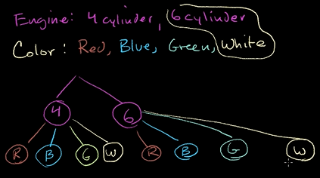
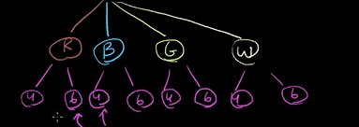

Counting outcomes: flower pots
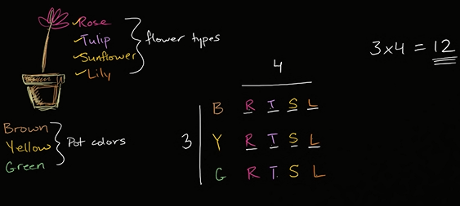

Permutation formula
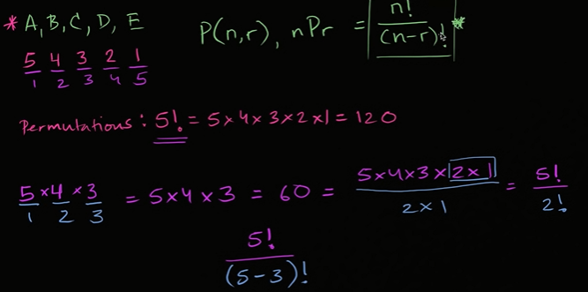

Zero factorial or 0!
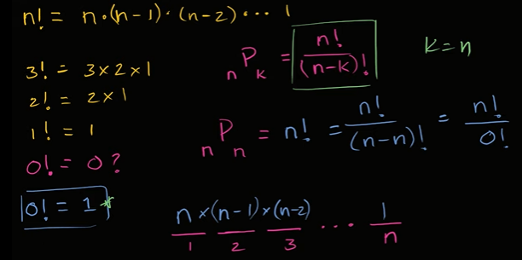

Factorial and counting seat arrangement

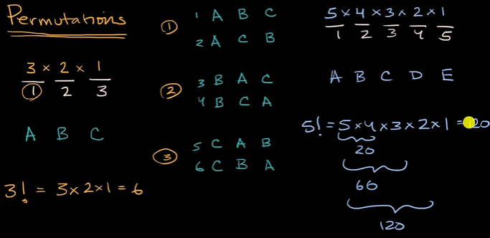
Possible three letter words
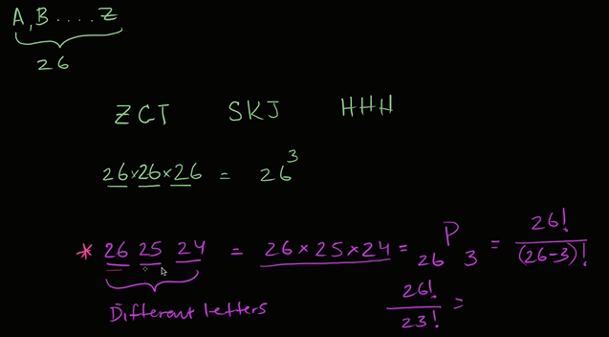

Ways to arrange colors
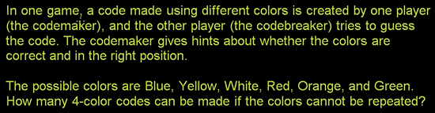

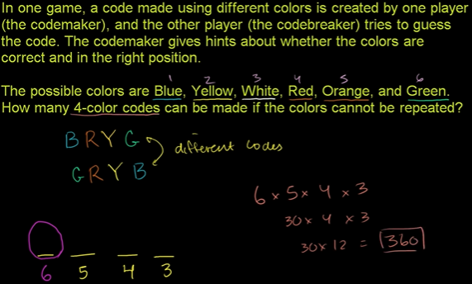

Ways to pick officers
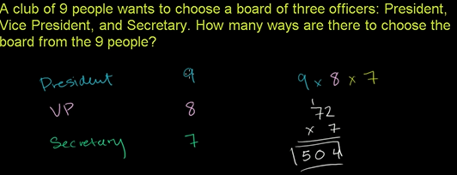

Combinations

Intro to combinations
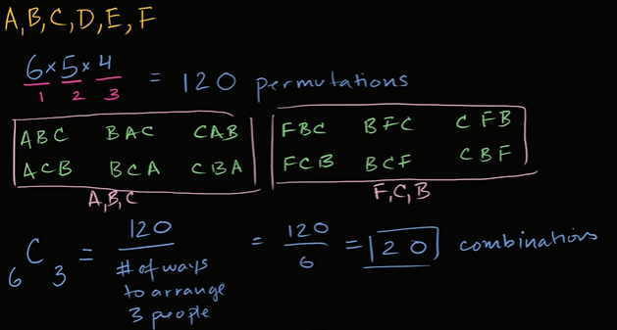

Combination formula
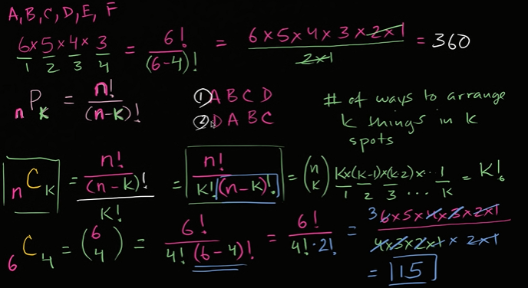

Handshaking combinations
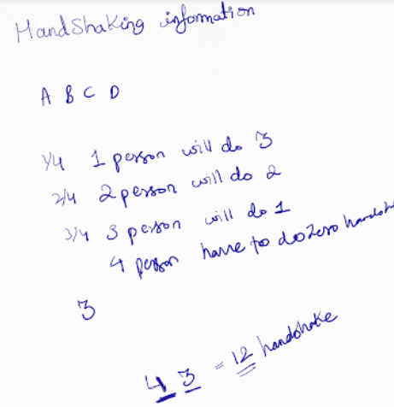

My problem was I was looking for ans.
They ask combinations of hanshake.
So I should think of creating combinations.
AB,AC,AD…. So on.

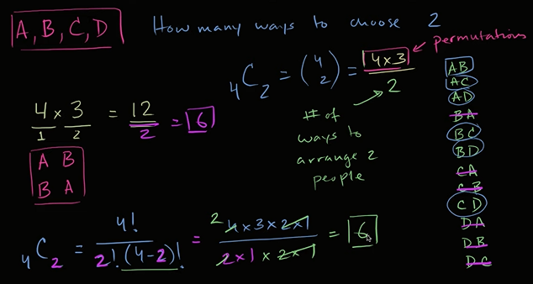

Combination example : 9 card hands
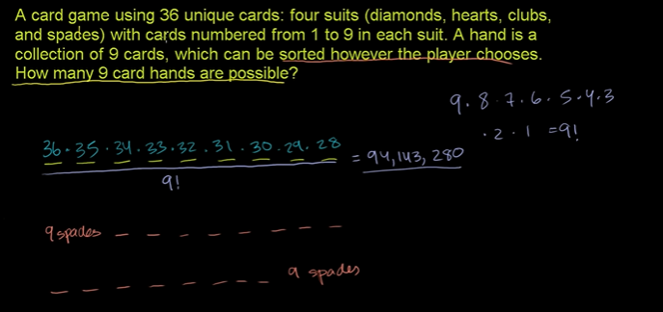

Combinatorics and probability

Probability using combinations
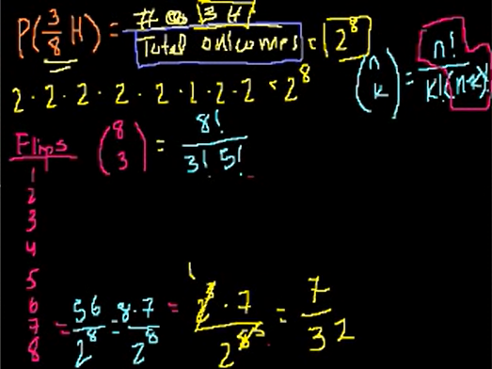

Here,
_ _ _
Out of 8 different flips we can get one of the head
Out of 7 different flips we can get one of the head
Out of 6 different flips we can get one of the head
Now we have permutations of 3 heads in 8 Flips
8*7*6
We need to divide by 3! cuz its treating 1st Head as different Head to 2nd and 3rd.
Imagine,
HHH TTTTT, TTTTT HHH, …..
For H1H2H3 TTTT, it would also give me H2,H1H3.
Its kk , its a bit confusing.

Probability & Combinations ( 2 of 2)
FT: Free throw
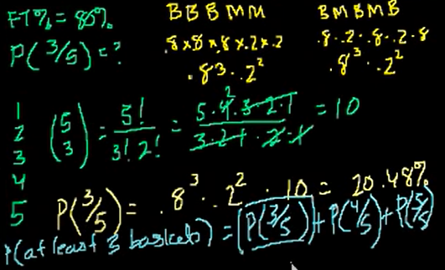

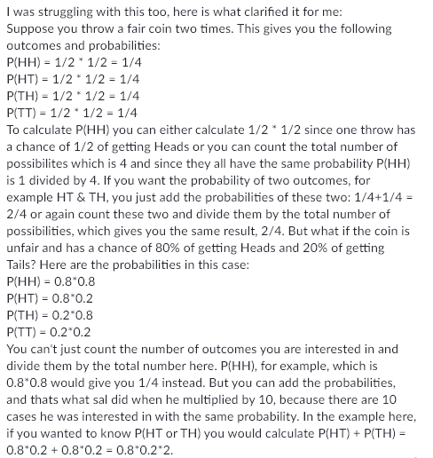

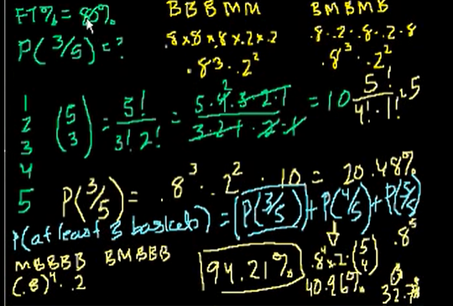

Example: Different ways to pick officers
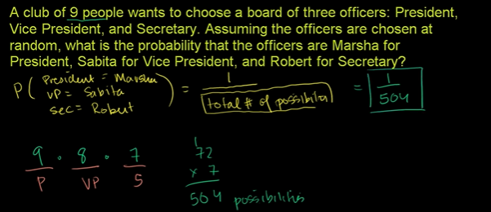

Example: Combinatorics and probability
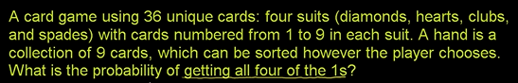

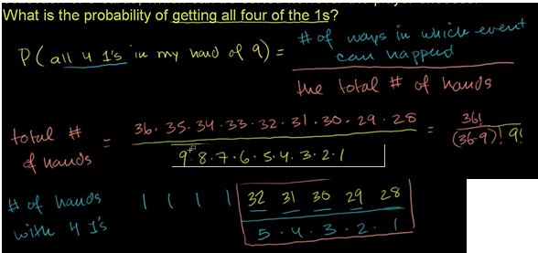
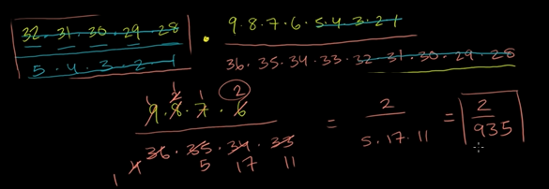

Getting exactly two heads ( Combinatorics)
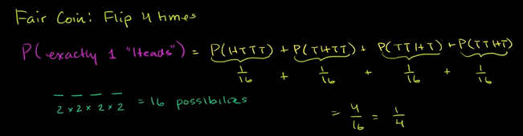

We can add proabability of this things cuz they are mutually exclusive. Any two of the things cant happen at the same time.
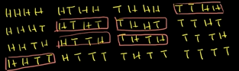

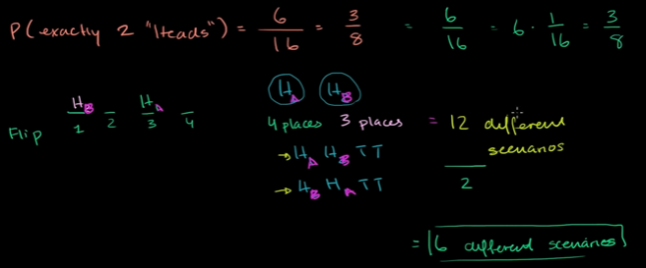

Exactly three heads in five flips
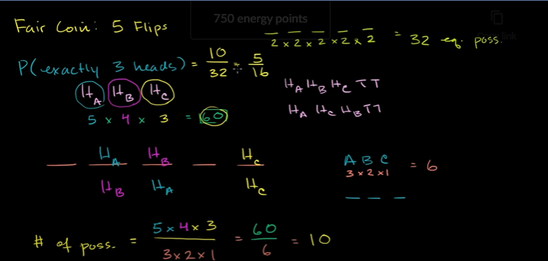

Generalizing with binomial coefficients ( bit advanced)
Skip

Lottery proabability
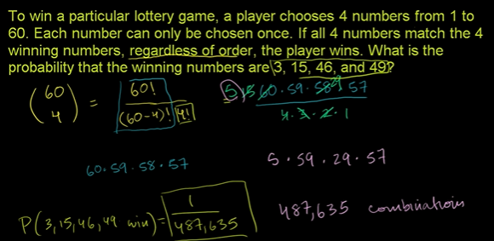

Conditional probability and combinations
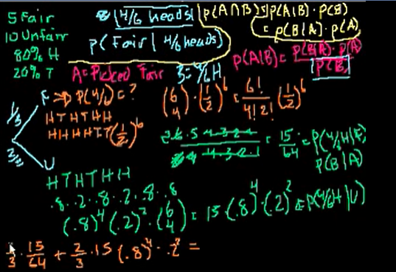

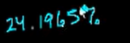

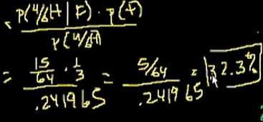

total proabability of getting a 4/6 head= P(fair| 4/6 Heads)+P(Unfair|4/6 Heads)
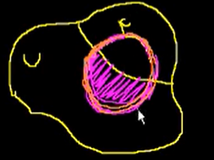
If we pick the fair coin we have 15/64 that I got 4/6 H.
Bayes theorem tells us we got 4/6 head. We r in this universe.
1/3 of the universe I.e 32.3% intersect with the
fair coin universe.

Mega million jackpot probability
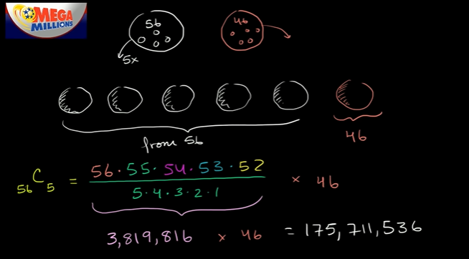

Birthday probability problem
Question: Probability of atleast 2 ppl sharing birthday?
